ANAT 260 Signature Assignment and Instructions

Instructions: In an APA research paper format address each question asked as it relates to the case study given. Use a minimum of 5 academic references, not including wikis, google, or blogs. You may include the Augmented Reality, and the Anatomical models as some references. Please ask the librarian how you could reference the AR and Models.
Please refer to the APA documents attached to this assignment as reference.

Case scenario
While working in the Emergency Department, a patient was brought in by ambulance with 2 arrow wounds. The first arrow is still in the patient on the left side, entering anteriorly between the 7th and 8th ribs in a 90 degree angle, the arrow head protruding posteriorly.
The 2nd arrow is located in the posterior cervical triangle.
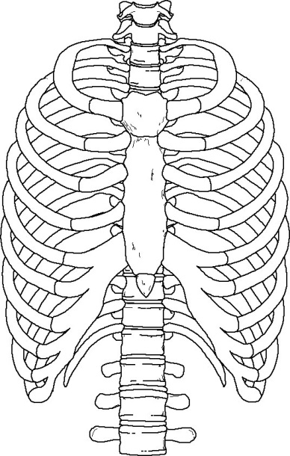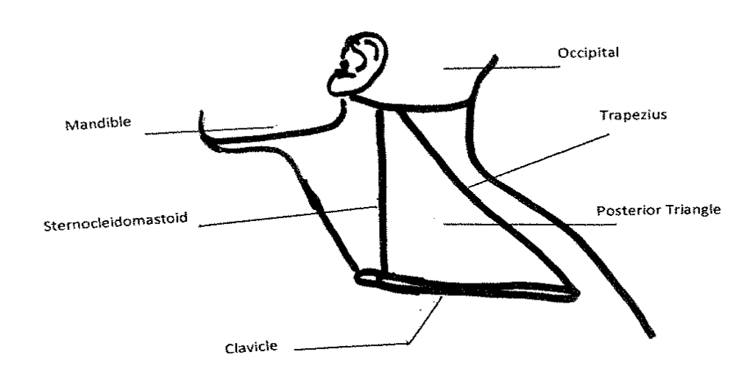
Question 1 (CLO 1, 4, 5, 6)
- What serosal cavities have been penetrated by the 1st arrow?
- Explain the location, the microscopic characteristics of the serous membrane, and the purpose of the serous membrane.
Question 2 (CLO 4, 5)
- Describe the Autonomic Nervous System.
- Explain how the patient’s ANS reacts to the arrow attack.
- How will this autonomic reaction affect the patient’s vital signs (Pulse rate, Blood Pressure, Respiratory rate, Temperature)?
Question 3 (CLO 1, 5)
- Describe the trajectory of the 1st arrow using directional terms and anatomical planes.
- Identify and describe the organs and any other membranes that may have been affected by the 1st arrow.

Question 4 (CLO 4, 5)
- Describe the cardiovascular structures (systemic and pulmonary components) that are affected by both arrows.
- Explain the effect of this cardiovascular injury on the Hematocrit and Hemoglobin values.
Question 5 (CLO 2, 3, 4, 5)
- Identify the possible neuromuscular effects of the 2nd arrow and explain your reasoning.
- Describe the components of a neuromuscular junction including key structures.
Question 6 (CLO 3, 4)
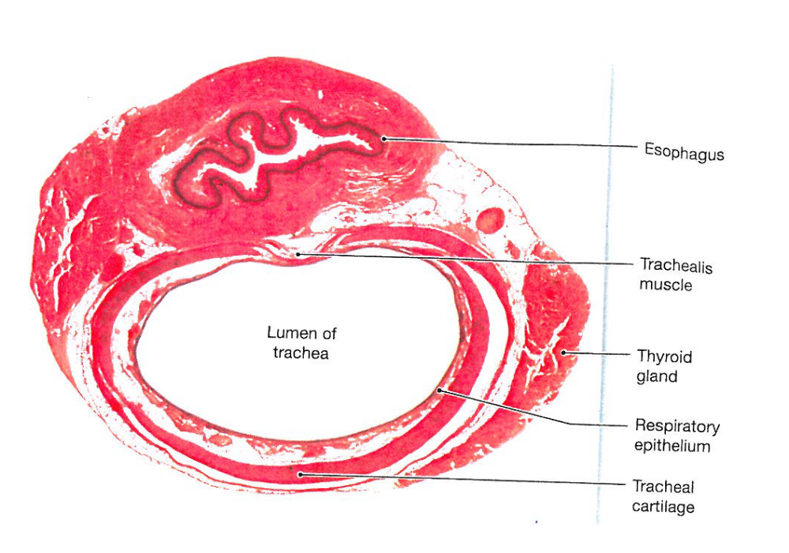
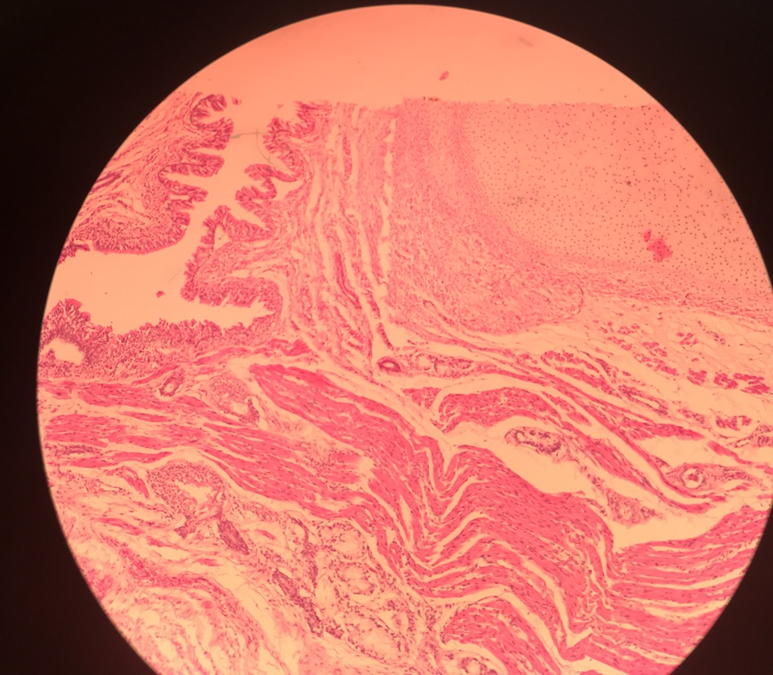
3
2
1
Trachea slide:
- Identify and describe all tissue types found in the last slide and specify the subcategories of these tissues. Use the following table as a guide.

- How will the injuries affect this area?

